Why only JUnit here?
Because your NumberService:
public int sumOfSquaredEvenNumbers(List<Integer> numbers)
- Has no dependencies
- No database
- No repository
- No external service
It’s just pure logic.
So we only need:
JUnit → to test logic
- reduce() combines all elements into one final value.
- It "reduces" many values → into one result.
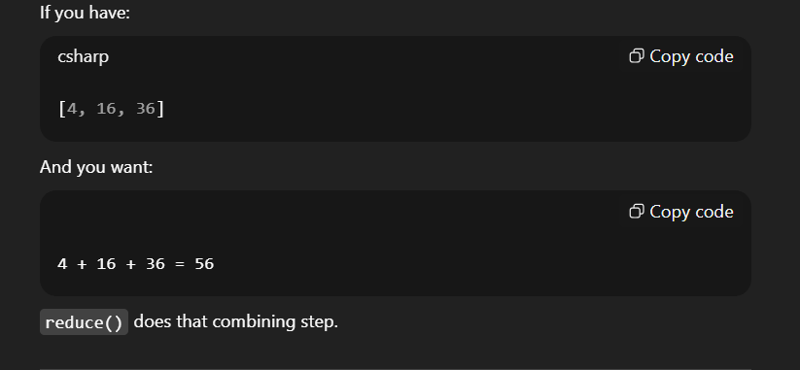
Use reduce() when you want:
- Sum
- Multiply
- Concatenate strings
- Find max/min manually
- Combine elements into ONE value
Method | Purpose
map | transforms each element
filter | removes elements
collect | gathers into container
reduce | combines into single result

filter → select
map → transform
reduce → combine

flatMap:
Input Type
List<List<Integer>> nestedList
[
[1,2],
[3,4],
[5,6]
]
This is a list of lists.
🔹 Step 1: nestedList.stream()
We convert outer list into stream:
Stream content:
[1,2]
[3,4]
[5,6]
Each element is still a List<Integer>.
🔹 Step 2: .flatMap(List::stream)
What does List::stream mean?
It means:
For each inner list, call .stream() on it.
